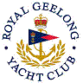 | Royal Geelong Yacht Club Inc.  Est 1859
Trophy Deed of Gift.

Trophy: | Winter Series Division One Aggregate Vase
Presented by: | Davidsons Accountants and Business Adviser
Date:
For: | Winter Series Division One Aggregate from 2015
Remarks / Revisions
Click here to View Recipients

